**Notebook Hands-on**

For this tutorial, we'll be using the Telecoms Churn Dataset. It consists of cleaned customer activity data (features), along with a churn label specifying whether the customer canceled their subscription or not. The two data sets churn-80 and churn-20 are from the same batch, but have been split by an 80/20 ratio. We'll use the larger set for training and cross-validation purposes, and the smaller set for final testing and model performance evaluation. The two data sets have been included in this repository for convenience.

1. Log in to your Watson Studio, click Create a project to start our journey.

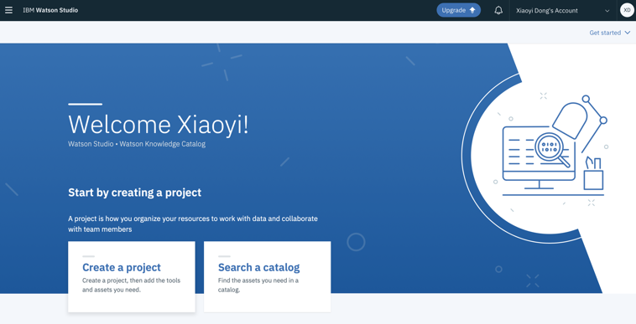

2.Click Data Science and AutoAI and then give a Name and Description of the project.





3. Click the blue button Add to Project



4. Select Notebook



5. Give a name and description of your notebook then set the Select runtime as Default Spark Python 3.6 XS



6. After creating the notebook

<https://github.com/Dylansafool/HandsOn-Notebook/blob/master/Customer_Churn.ipynb>